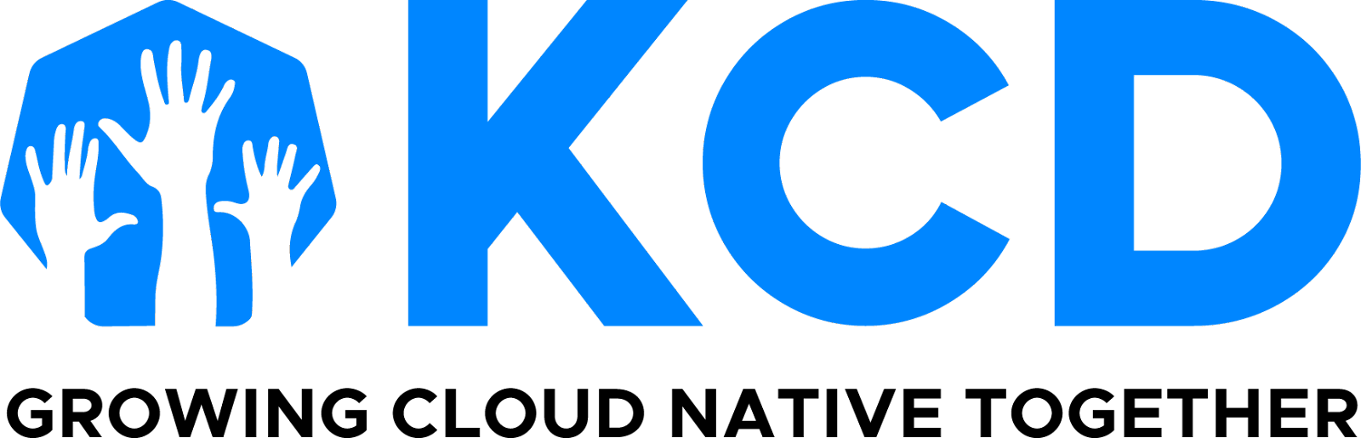

KCD Monthly Organizer Digest

October 4, 2024

## **Congratulations Lahore, Sydney, Washington DC, and Porto!**

Four KCDs were hosted in the month of September, with KCD Porto executing their inaugural event!

We are excited for the next four KCDs happening this month!

* [KCD Austria](https://community.cncf.io/events/details/cncf-kcd-austria-presents-kcd-austria-2024/) happening October 9-10
* [KCD Chattogram](https://community.cncf.io/events/details/cncf-kcd-chattogram-presents-kcd-chattogram-2024/) is virtual on October 12
* [KCD UK](https://community.cncf.io/events/details/cncf-kcd-uk-presents-kubernetes-community-days-uk-london-2024/) happening October 22-23
* [KCD MENA](https://community.cncf.io/events/details/cncf-kcd-mena-presents-kcd-mena-2024/) on October 17

**horizontal line**

NEWS

## **2025 KCD Application Notifications**

Thank you to 61 applicants for your 2025 KCD submissions! We had:

* 1 submission in Africa
* 28 submissions in the Asia Pacific
* 14 submissions in the EU & UK
* 12 submissions in the South & Central Americas
* 6 submissions in North America

**Blog post**

We will publish a detailed blog post with the announcement of the accepted KCDs in mid October. This will include the criteria we used to make this decision, and the team it took to review.

## **Also… KCDs Finally Have a LinkedIn Page!**

| [**Follow us**](https://www.linkedin.com/company/kcds-by-cncf/) |
| --- |

**horizontal line**

OPPORTUNITIES

## **Kiosk Sign Up at KubeCon + CloudNativeCon North America**

A few of you have asked to help in the project pavilion kiosk at KubeCon + CloudNativeCon Salt Lake City in November. So here is the signup form for those of you who want to...

1. promote your KCD
2. or talk about your KCD planning experience

If you are also a CNCG organizer, then please feel creative and talk about both, and how you bring events and meetups to your local community.

| [**Fill in your availability**](https://forms.gle/3V1xN4FVA7Jrdxgq5) |
| --- |

## **KubeCon + CloudNativeCon Europe 2025**

In case you did not see the notification that went out on Tuesday, there is a call for program committee members. On behalf of Cloud Native Computing Foundation, we are excited to announce [KubeCon + CloudNativeCon Europe 2025](https://events.linuxfoundation.org/kubecon-cloudnativecon-europe/) taking place 1-4 April, 2025 and invite reviewers with technical expertise to submit their interest as a program committee member!

Please review the [Important Dates and Program Committee Responsibilities](https://events.linuxfoundation.org/kubecon-cloudnativecon-europe/program/submission-reviewer-guidelines/#important-dates-to-remember) before submitting your interest.

Sign up by Friday, 15 November at 11:59 pm PDT in order to be considered.

| [**Sign up**](https://forms.gle/iVbXmRgzKkEzs2Fa6) |
| --- |

**horizontal line**

As always, thank you for helping make cloud native ubiquitous in your spare time.

Audra Montenegro

CNCF Community Program Manager

[**About KCDs**](https://www.cncf.io/kcds/) **|** [**KCDs GitHub Repository**](https://github.com/cncf/kubernetes-community-days/blob/main/README.md) **|****KCDs on** [**LinkedIn**](https://www.linkedin.com/company/kcds-by-cncf/) **&** [**Twitter**](https://twitter.com/KubernetesDays)

**US Time zone: Pacific**